 | Technical Rescue Gear Pre- Use Inspection
Employee Name |  | Inspection Date
Harness Model |  | Serial Number
Connector Model |  | Serial Number
Harness
 | Check the following | Pass | Fail
 | Webbing (cuts, burns, wear etc.)
 | Load-bearing stitching (cut, worn, or pulled threads)
 | D-Rings (deformed, marks, wear, corrosion)
 | Adjustment buckles/ grommets (deformed, marks, wear, corrosion)
 | Connectors (cracks, marks, wear, deformation, corrosion)
 | Manufacture tags
 | Webbing strap is properly threaded through buckles
 | Operation of the adjustment buckles
- Fails Inspection
- Passes Inspection
Signature: _________________________________
Pulleys and Archers
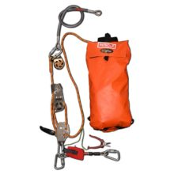 | Check the following | Pass | Fail
 | Snap Hook/ Carabiner (deformed, marks, wear, corrosion)
 | Connector (crack, marks wear, deformation, corrosion)
 | Pulley (seized, crack, marks wear, deformation, corrosion)
 | Manufacture Tags
 | Anchor (deformed, marks, wear, corrosion)
- Fails Inspection
- Passes inspection
Equipment Type: _______________________ Serial Number: ______________________
Signature: _________________________________

Rope Bag
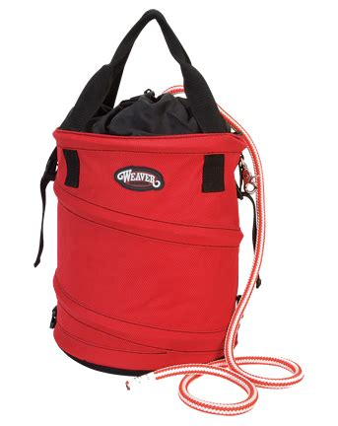 | Check the following | Pass | Fail
 | Load-bearing stitching (cut, worn, or pulled threads)
 | Manufacture tags
- Fails Inspection
- Passes Inspection
Signature: _________________________________

Serial Number | Employee Name | Pass | Fail | Initial

Using This Form- A pre-use inspection MUST be conducted on each shift in which fall protection equipment is used. After the first inspection of the week, subsequent inspections may be recorded on the table above.
This document must be submitted to your General Manager at the end of the week (Friday), or the end of the project, whichever is sooner.

